ASSIGNMENT – 1
DDL COMMANDS (Create, Alter, Drop,)

- Create Command - CREATE command is to define the structure of an object before storing data in it.

CREATE TABLE Restuarant(
Order_ID INT,
Customer_Name VARCHAR(50),
Customer_Phone_Number VARCHAR(100),
Cuisine_Name VARCHAR(100)
);

INSERT INTO Restuarant VALUES
(101,'ABC',1234567890,'NorthIndian'),
(102,'DEF',4455667890,'SouthIndian'),
(103,'GHI',7745362846,'Chats'),
(104,'JKL;',9905468462,'Chinese'),
(105,'MNO',6635284642,'Japanese'),
(106,'PQR',7130184627,'Continental');

SELECT * FROM Restuarant;

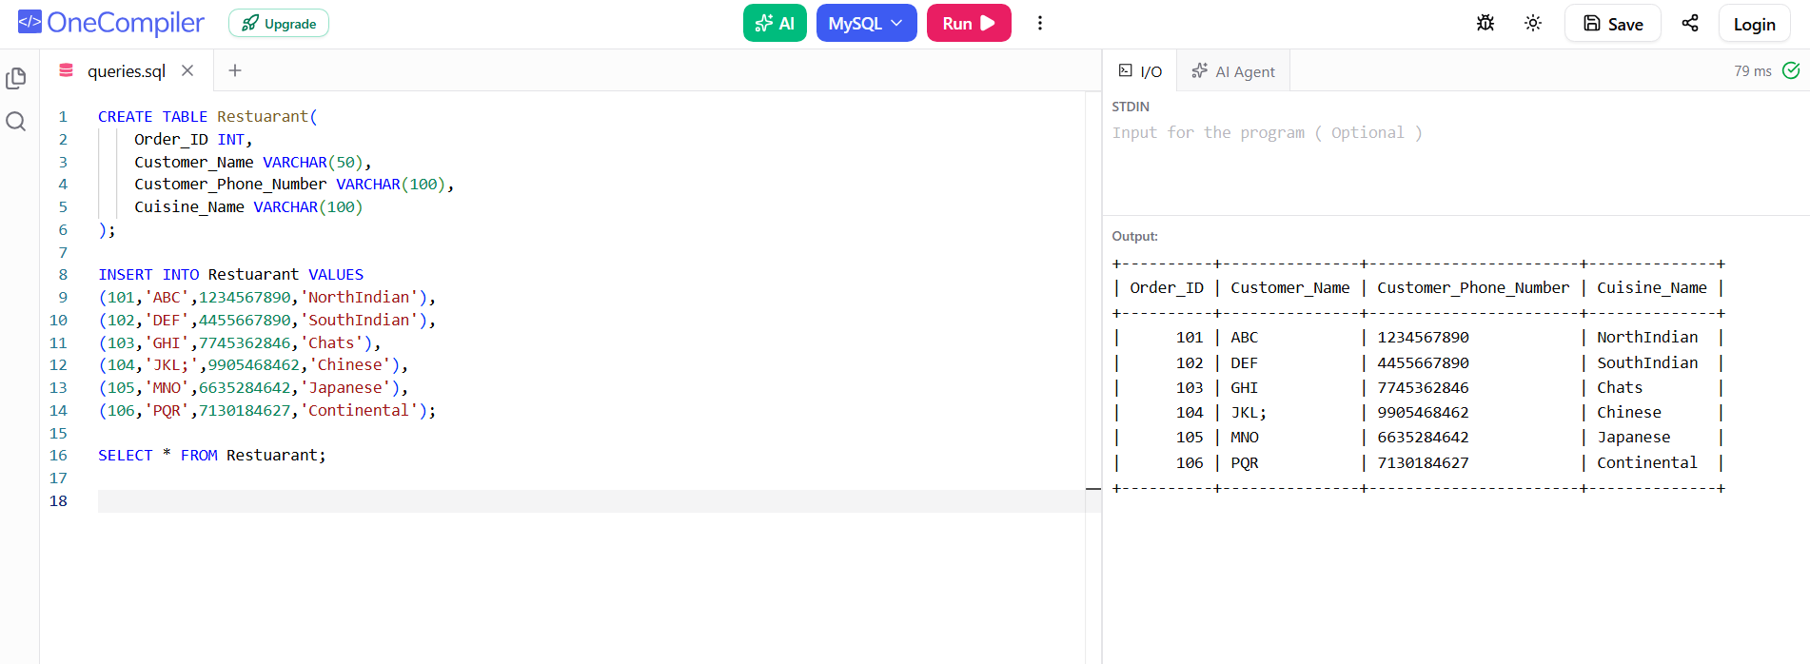
- Alter Command - Used to modify the structure of an existing table without deleting it.

ALTER TABLE Restuarant
ADD Order_Price INT;

SELECT * FROM Restuarant;

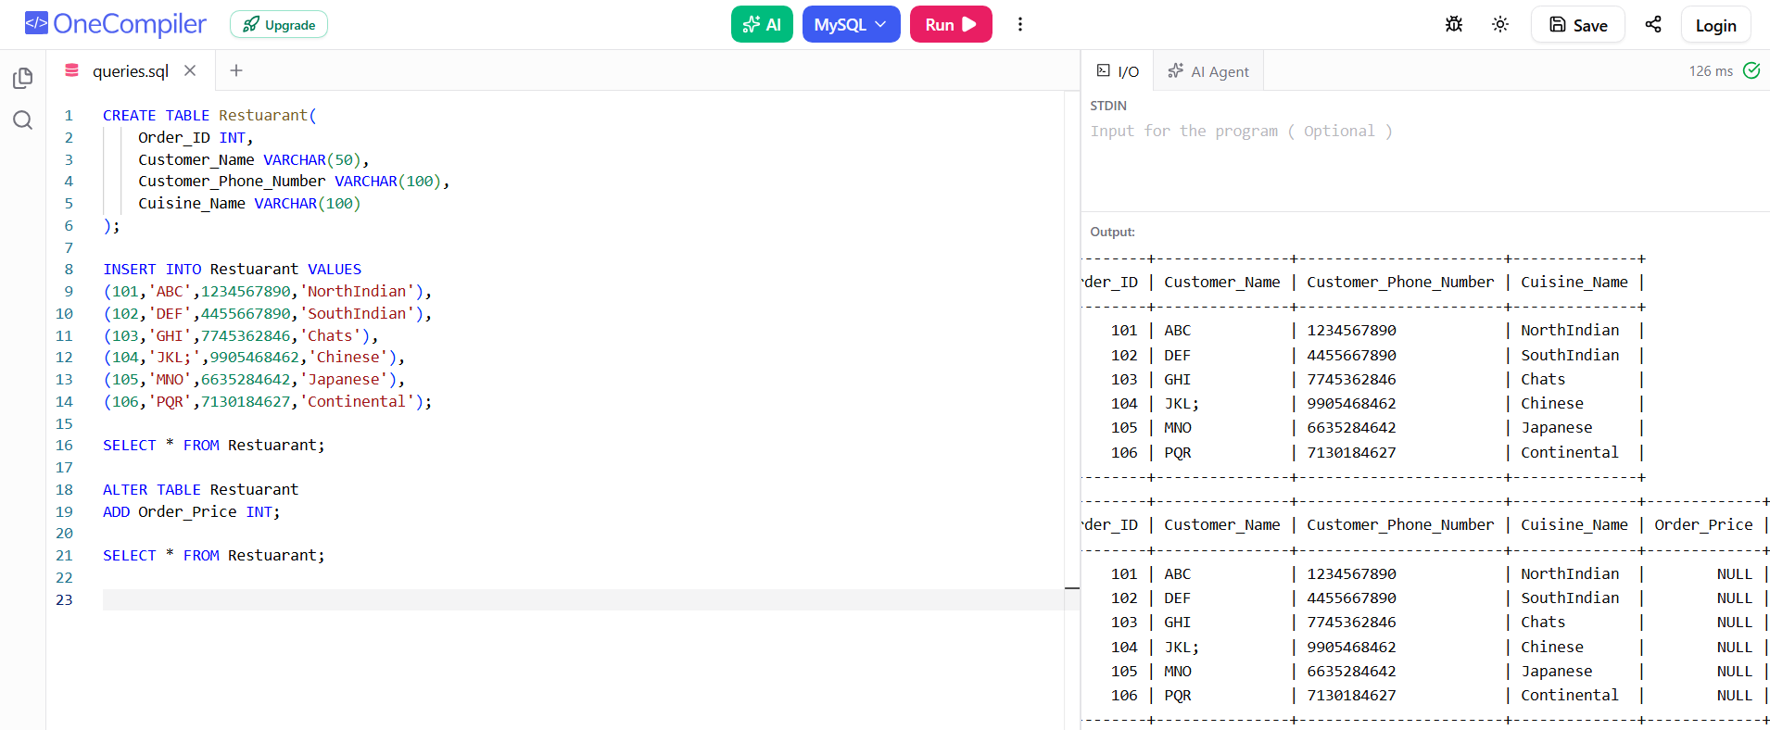

- Drop Command - Command used to permanently delete a database object such as a table, database, or column.
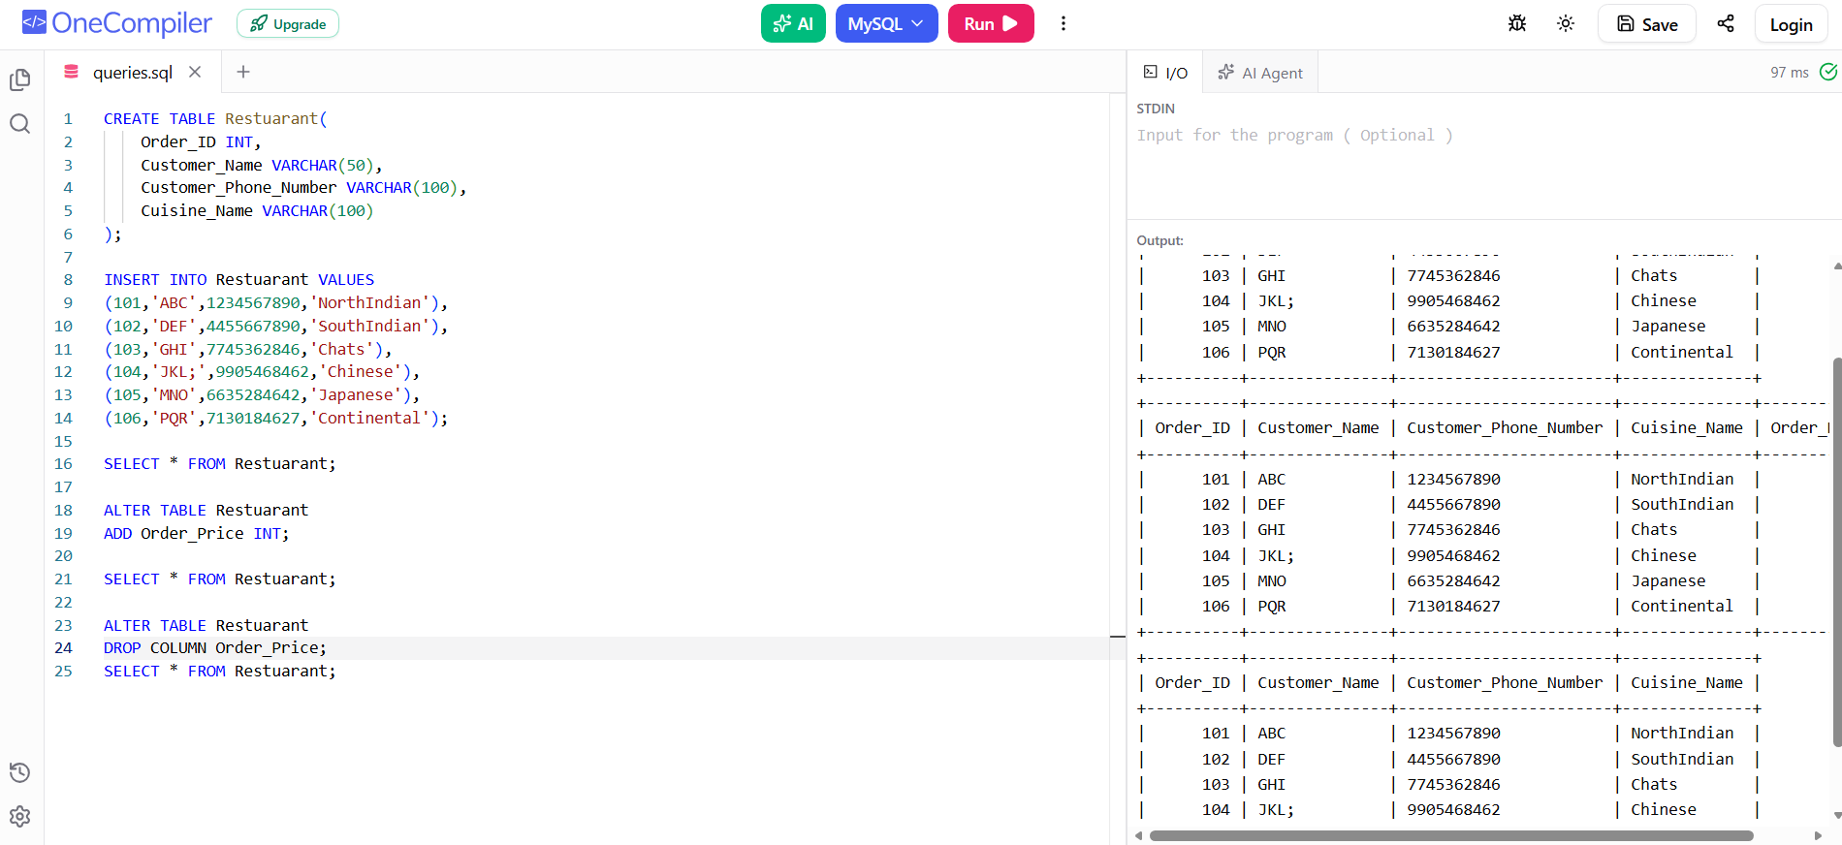
Github Link - https://github.com/mohith-1817/DBMS-ASSIGNMENTS.git

